Partner organisation

New Organization ID (2020)

PIC

Full legal name (National Language)

Full legal name (Latin characters)

Acronym

National ID (if applicable)

Department (if applicable)

Address

Country

Region

P.O. Box

Post code

CEDEX (only for France)

City

Website

Email

Telephone 1

Telephone 2

Fax

E10184065

922540520

Πολιτιστικός Οργανισμός Μακεδονίας –Θράκης

ΕΣΑΕΙ ΕΝ ΡΟΗ

ESAI EN ROI Cultural Organization of Macedonia - Thrace

EERcomt

27639

Dept. of EU Project Management

4, EratosthenousStr., AnthokipoiPolichnis

GREECE

N. Thessalonikis, Central Macedonia

---

56429

Thessaloniki

http://esai.gr/eer

eu@esai.gr

+306906982244

+306936597376

+302314042342

Profile

Type of organization

Is the partner organization a public body?

Is the partner organization a non-profit?

Non-governmental organisation/association/social enterprise
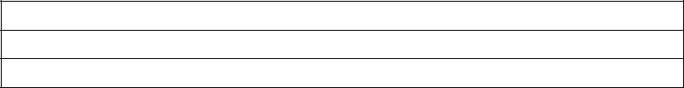
No

Yes

Accreditation

Has the organization received any type of accreditation before submitting this application?

Accreditation type | Accreditation reference
European Voluntary Service | Project Code 2018-1-EL02-KA110-003788
European Solidarity Corps | Quality Label as Supporting and Hosting Organization (2019)

Background and experience

Please briefly present the partner organization.

Esai en Roi Cultural Organization of Macedonia – Thrace is a Cultural Association activated in the Fine Arts era, in Cultural conscience & Cultural issues related to "Quality of Life" and "Sustainable Environment" development. EER is strongly connected to Fine Arts Innovation, Research & Education and supports youth activism via creativity and arts. Through regular artistic activities and festivals EER facilitates Artists’ sociability and Cultural Heritage vigilance.

EER cooperates with public authorities and private associations or companies sharing common aims or interests. Between 1997-1999, EER was a non-formal group of artists. Since 2013 EER festivals have been acknowledged for their importance as to be nominated “under the aegis” of Ministries of Tourism, Infrastructure & Transport, Culture

- Sports, Education, Foreign Affairs & Interior (Macedonia -Thrace Region).
EER Activities: EER collaborates with other institutions and Associations related to Fine Arts, Tradition, Research, Health and Education, Sustainable Environment, Social Solidarity and Quality of Life aiming at the linear quality development of EER services to contemporary social needs and ICT standards. EER participates in research & innovation projects relevant to Sports and Fine Arts in education, Health, Ecosustainability, Elite performance, Innovation and Social Solidarity. For more about our Annual Activities, please visit our official website http://esai.gr/eer under the label SERVICES > “Projects”.

What are the activities and experience of the organization in the areas relevant for this application?

EERcomt & YOUTH


We strongly believe that quality of life could be generated through sharing the opinion that «everybody is as important as to influence community’s social status and cultural development». Youngsters are by nature the most appropriate age-group as to attract the entropia of a better world. They just need guidance and support to learn how to use their power and how to build self-protection through setting personal limits according to their needs and desires without annoying or disturbing the common «good». Thus, EER supports Youth Actions and Young Artist Activities claiming their importance in Social Life via Arts & Physical Rehabilitation in Society.

ACTIVITIES

Our volunteers are mainly young people who are seeking opportunities for personal development or are interested in gaining professional experience in the sector of performance and visual arts. Some of our members are also interested in supporting activities of social interest or have a minority social profile (youth with fewer opportunities, learning difficulties, mild mental disorders, disabled, etc). EER is interested in projects supported by the European Solidarity Corps, KA1, KA2, KA3 erasmus+ and Creative Europe Projects.

EER QUALITY & IMPACT

EER has an experience of over 20 years in project management of short term projects. During the last three years, we have been coordinating more complex activities of annual duration. Our activities are under the aegis of Ministry of Interior (Sector of Macedonia - Thrace) & in some cases enjoy the support or quality accreditation of Ministry of Education & Religion & Ministry of Culture & Sports.
EER is: an official member of the International SKILLMAN Network in the educational sector operating as an Area Coordinator; is subscribed in the Portal of Cultural Associations of the Ministry of Culture; is accredited with the badge of Socially Responsible Organization 2020 in Sports era; is a member of the "Youth Work Today" Community of Professionals; is an ESC & EVS Accredited Organization; is a member and is supported by the Life Beyond Funding Campaign.In 2021 EER was awarded with the Best Health and Wellness Award via Arts and Sports (by GHP International) and in 2022 it achieved an official membership in Global Waste Cleaning Network.

COLLABORATIVE PROJECTS

EER collaborates with institutions and associations related to Fine Arts, Tradition, Research, Health and Education, Sustainable Environments and Quality of Life aiming to upgrading the quality of its services linear to contemporary needs and ICT standards. Some of the most important and regular affiliated partners are the Institute of Nutritional Research & Education (support in QoL activities), Konstantinion Research Center of Molecular Medicine and Biotechnology (EER implication in Research), Children’s Creativity Center KDAP PLATON, Club of Sign Language Distribution, etc.

RESEARCH ACTIVITIES

EER is participating in research projects related to Fine Arts and: a) education, b) health, c) elite performance, d) innovation and e) the Disabled. EER SOCIAL MINORITY ACTIVITIESEER is supporting Social and Special Population Minorities to participate in Art-Creation & Sport activities in a manner that promotes the positive rather the negative options and perspectives of their social identity. Disabled communities participate in the annual festival of Inclusive Culture, in which we are one of the four main coordinators. Moreover, disabled youth between 15 and 25 years old are able to actively participate in activities of talent promotion in the field of arts and in all of our other activities, offering services, promoting the activities or participating in them (https://esai.gr/dhias.html).

Our upcoming festival, the handiedancefestival, focuses on creative minds with innovative ideas and contemporary fast-track skills and competences acquisition in the Fine Arts area. (www.handiedance.com)

CAREER ORIENTATION AND TALENT PROMOTION in ART-RELATED OCCUPATIONS

EER core has a department concerning professionalism and career practice of youth. That is the EER Department of Dance-theater. Since 1997, EER has been regularly producing dance-theater and dance performances, cooperating with several dance-companies, performers, choreographers, directors, musicians, scenography designers and technical assistants. The productions concern and deal with Greek topics of social interest or Greek culture and tradition. Moreover, since 2004 EER has been organizing and realizing young artists' nights and since 2017 screening tests for young talents in Fine Arts
(https://esai.gr/talent.html).

ECO-PROJECTS

EERcomt premises are located near a former military camp, now a park without clear identity: nowadays it is being claimed by many public and private bodies, which are arguing about its final formation and use. We are trying to promote the idea of developing the area to one of the largest city-parks and to communicate to citizens and authorities that where green is less, pollution is elevated. Our planned activities are sports & artistic events and campaigns about the park and its hidden treasures! Since autumn of 2019 we have been trying to include those activities in ESC. We have also been participating in several local Eco-campaign activities of our region, i.e Pavlos Melas Municipality of Thessaloniki Region https://karatasoupark.org.
Publications

EERcomt takes pride on its own sector of Publishing. Our publications are open to public and are related to EERcomt actions, activities and aims.

EER CLUBS

- Artistic club very Monday with EER artists guiding and supporting the making of several creations within the park area, interacting with the natural environment, recycling, etc. Also recommended for the disabled population.
- Sports Club every Wednesday and Friday; fitness sessions by utilizing bike or running routes that EER Volunteers created; cleaning the park; taichi, crossfit, yoga, aerobics, fitness sessions depending the will of the group and the trainer/ supervisor that leads the group.

- EER mind game clubs: every Sunday several mind games available to all,with the presence of volunteers throughout a non formal learning process (learning by others).
- EER touring: within Karatasou park or nearby parks and out of the city (by bus) depending on participation. This is organised every 2 months (February, April, June, August, October, December).
- EER handiedance events: appropriate also for schools (several visits to schools after being invited) and every 2 months a special event within a city park (every January, March, May, July, September, November).

Please give information on the key staff/persons involved in this application and on the competences and previous experience that they will bring to the project.

EER DEPARTMENTS

Our main core consists of volunteers of various nationalities and professions outside EER context. Our members are circulated and are not always active within the year span but shift according to their interests and type of engagement. Our main staff deals with the logistics and project management issues. Our organization cooperates with the following companies for administration and technical support: (a) GROMA reconstructions [https://www.groma.gr/]; (b) Rachatopoulos Accounting Office c) other external professionals signing project contracts depending on the case.

EER is sub-divided into four different departments:
DEPARTMENT OF MANAGEMENT & ADMINISTRATION
It consists of six main posts that are filled by people that work in administration: a counselor at law, an accountant; a project manager; a web-manager; a graphic designer and a technician. Those persons are occupied according to the needs of the organization -mainly part-time at present. This Department coordinates the:
DEPARTMENT OF ANNUAL ACTIVITIES
Our annual activities are supported financially by Erasmus+ and European Solidarity Corps and are listed at: https://esai.gr/eer. The activities are furthersupported by local or regional sponsors of the private and public sector. Finally, EER is financially supported by its members for its basic functional costs. All sponsorships are received in material, not in cash.
DEPARTMENT OF EXTERNAL PROFESSIONALS

EER is connected to a huge network of professionals with excellent performance and distinctions in their field of expertise. Most of them are teachers of Primary or Secondary Education, academics in the field of Fine Arts, Education, Architecture, Health Professionals and individual researchers. According to EER needs, invitations of interest are published with newcomers always being welcome and this resulting to our network’s extension.

DEPARTMENT OF VOLUNTEERS

Our volunteers, if occupied for a few hours for basic administration support, are trained just a few days before the main event. If they have a leading role they are obliged to attend our training courses concerning volunteerism and basic axioms. Volunteers can be of any age.

KEY STAFF

Eleni Kavazidou, Msc, PhD specialized in Sports, Music and Dance. She has an Msc in Physical Education of Special Populations, characterized by physical impairment, mental, physical or mental disorders. She has been specialized in Dance/Movement Therapy and studied on Eating Behavior of mentally disordered populations. She has a strong background in research activities with several publications and is author of 3 books related to movement and dance. She is experienced in various EU programs and national projects. For several years she was a coordinator of courses, projects and trainings in Primary Schools concerning health, sustainable environment, cultural issues and career orientation topics. She is the EERcomt Projects Supervisor. She speaks English (C2), German (A2) and continues her linguistic studies with Italian and French.

Thomai Meladini, is EERco Secretary and administration tasks support. She supervises all Youth Activities. She is our Social Mentor.

Nikolaos Kavazidis is our public relations manager and develops our dissemination strategies. Several Youth workers and EERcomt officers support our activities and are available for facilitating or implementing EU projects.

Paris Ioannidis is EERcomt technician, musician & music composer. He supports EERco in web design, graphic designs, new technologies and is the composer of EERco productions. He supports all annual EERcomt activities through supervision of volunteers, networking of associated partners and technicians within affiliated partners and support of new talents in the music sector.

Legal representative

Title

Gender

First name

Family name

Department

Position

Email

Telephone 1

Dr.

Female

Eleni

Kavazidou

Department of EU Project Management

President

esai@esai.gr

+306906982244

If the address is different from the one of the organization, please tick this box

Contact person

Title

Gender

First name

Family name

Department

Position

Email

Telephone 1

Ms.

Female

Natalia

Banti

Department of EU Project Management

Language Facilitator, Communication Manager
natalia.banti@gmail.com

+306974820189

If the address is different from the one of the organization, please tick this box

EU Programme |  | Year | Project Identification or Contract | Applicant/BeneficiaryName | Title of the Project
 |  |  | Number
Erasmus+ KA153 |  | 2023 | 2021-2-HU01-KA153-YOU-000039291 | MOSTart Nemzetkozi Kulturalis Kozcelu Egyesulet | Travel around Thinking and Sharing with Images for Intercultural and Mutual Understanding
Erasmus+ KA153 |  | 2023 | 2022-1-HU01-KA153-YOU-000066488 | MOSTart Nemzetkozi Kulturalis Kozcelu Egyesulet | Travel around our mind and soul – Get deeper in our emotional intelligence for creating a diverse and inclusive youth work
Erasmus+ KA105 |  | 2022 | 2020-2-MT01-KA105-074262 | NECI Malta | Youth Environmental Project
Erasmus+ KA105 |  | 2022 | 2020-1-IT03-KA105-018571 | Vedogiovanne | Sport Actions 4 Inclusion
Erasmus+ KA151 |  | 2022 | 2021-1-BG01-KA151-YOU-000005038 | Learning for Change Foundation | Living nature - nature-based practices for personal and professional development of youth workers
Erasmus+ KA152 |  | 2022 | 2021-2-EL02-KA152-YOU-000040526 | EER | Push Up Sports and Arts Balkan
Erasmus+ KA154 |  | 2022 | 2021-1-EL02-KA154-YOU-000012405 | EER | Rethinking Youth – The Future in our Hands
Erasmus+ KA105 |  | 2022 | 2020-2-HU01-KA105-078962 | MOSTart Nemzetkozi Kulturalis Kozcelu Egyesulet | Spotting Your Blind Spots; Let's Explore Our Unconscious Bias
Erasmus+ KA105 |  | 2021 | 2020-2-BE04-KA105-002762 | asbl Loryhan | StéréoTrip
ESC11 |  | 2020-2022 | 2020-2-EL02-ESC11-005955 | EER | KAIZEN Youth for Health
ESC11 |  | 2020-2022 | 2020-1-EL02-ESC11-005770 | EER | Young Active Cit izens support Ecological Actions
Erasmus+ KA105 |  | 2020 | 2019-2-RO01-KA105-64322 | Vedogiovane | We are the Challengers
Erasmus+ KA105 |  | 2019 | 2019-2-RO01-KA105-064322 | Team 4 Excellence | Media 4 You
Erasmus+ KA105 |  | 2019 | 2019-1-IT02-KA105-016093 | Vedogiovane | Together We Live
Erasmus+ EVS |  | 2018 | 2018-2-EL02-KA125-004348 | EERcomt | Maximize Arts and Creativity AUTUMN
Erasmus+ KA105 |  | 2018 | 2018-2-HU01-KA105-47886 | MOSTart Nemzetkozi Kulturalis Kozcelu Egyesulet | Unleash Your Creativity & Bring Great Ideas to Life
Program YOUTH Youth Exchange |  | 2006 | 1.1/R1/2006/33 | EERcomt | Tasty Art Pollution
Program YOUTH Euromed Youth Exchange |  | 2005 | GR1.2.-14-2004-R5 | EERcomt | Folklore meets Progressive
Travel Costs
In accordance with the decision of the travel expenses of the European Commission and Erasmus +, calculate mileage

is calculated push on the calculator, from place of registration the organization (Town: THESSALONIKI, Country:

GREECE) to the venue of activities.
http://ec.europa.eu/programmes/erasmus-plus/tools/distance_en.htm

Have you participated in a European Union granted project in the 3 years preceding this application?



EERcomt Quality Certification:

Official Member of the SKILLMAN Network

Registered Cultural Organization in the Main Directory of
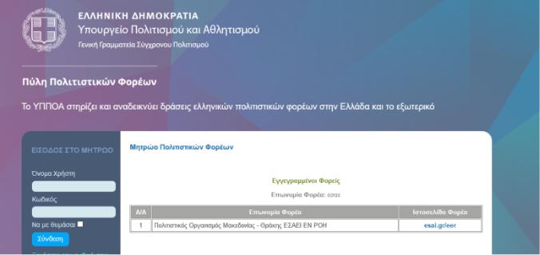

Greek Cultural Associations by the Ministry of Culture and

Sports

Accredited with the Badge of "Socially Responsible Organization" | Member of the Youth Work Today Community | Member of the International Virtual Exchange Network | Member of the Life Beyond Funding Campaign
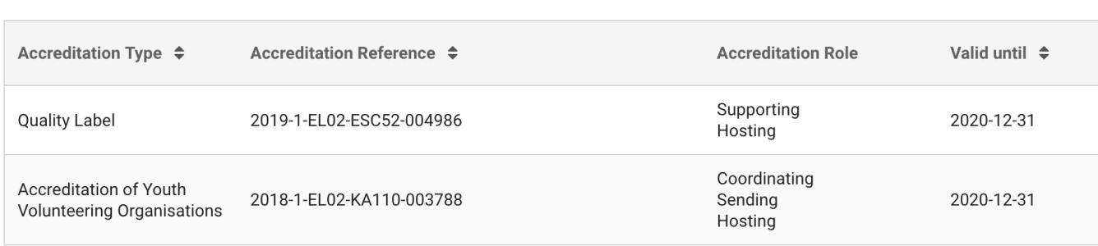
ANNEX

ACTIVITIES 1999-2019

EERcomt as a coordinator of the following activities of national or international level:
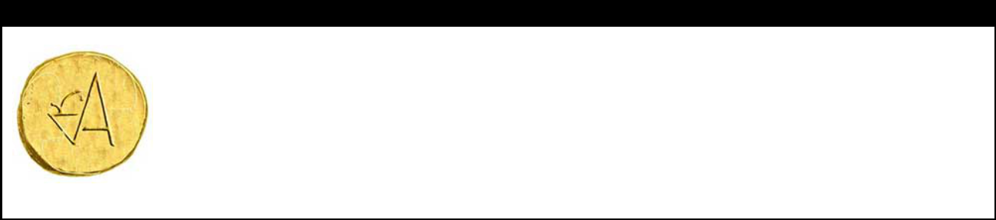

Deaf and Hearing People Festival of Inclusive Culture 2013-

http://esai.gr/dhias.html

A festival that promotes activities where people with different abilities or disabilities, impairments or differences communicate and cooperate as actors, teachers, athletes or spectators and enjoy activities of healthy lifestyles, for example, walking, climbing, running, cycling, sailing, singing, plaything theater, dancing, painting, etc. In 2020 the festival takes place in 8 cities : Chania, Athens, Nafplion, Preveza, Dion-Olympus, Thessaloniki, Thasos, Maronia-Sapes. The festival runs every year within the context of EUROPEAN WEEK OF SPORTS and with the cooperation of GR General Secreteriat of SPORTS (Ministry of Culture and Sports).


Terpsichore Award 2004-

http://esai.gr/awards.html

The result of yearly research about an important artistic personality that offered to the development of the dance art in Greece and wider.

Until the present time, the award is nominated to artists that offered to the development of art of dance in regional and national level. Some of the honored artists had international career and are famous worldwide (as for instance, Daniel Lommel, Gesch Michof, Dino Fanara, Kyrki AgrafiotouAmalia Strinopoulou, Dora Stratou, Amalia Strinopoulou, etc).

The CV of the artist is published in the Magazine of Alternative Culture INDEPENDENT.GR & the analysis of the biography is often provided with the accompanyement of EERcomt specialized staff, to students of Secondary Education.


Melthaleia Award 2018-

http://esai.gr/awards.html

The result of yearly research about an important artistic personality that contributed to the development of drama & acting in Greece and wider.

Until the present time, the award is nominated to artists that offered to the development of art of drama in regional and national level. In 2020 the award is nominated to the famous actress and politician MELINA MERKOURI. The year 2020 has been entitled from the Greek Ministry of Culture and Sports as year in favour/ memory of Melina Merkouri.

The CV of the artist is published to the Magazine of Alternative Culture INDEPENDENT.GR & the analysis of the biography is often provided with the accompanyement of EERcomt specialized staff, to students of Secondary Education.


Eyterpe Award 2019-

http://esai.gr/awards.html

The result of a yearly research on an important artistic personality that offered a lot to the development of music in Greece and wider.

Until the present time, the award is nominated to artists that offered to the development of music in international level. In 2019 we honored Reggina Reinhard Stamatiadou and in 2020 we are going to honor Mikis Theodorakis.

The CV of the artist is published to the Magazine of Alternative Culture INDEPENDENT.GR & the analysis of the biography is often provided with the accompaniment of EERcomt specialized staff, to students of Secondary Education.


Polymnis Kalliepousa 2020-

http://esai.gr/awards.html

The result of a yearly research on an important artistic personality that contributed to the development of conjectural arts in Greece and wider.

Until the present time, the award has been given to artists that contributed to the development of conjectural arts in regional level. In 2020 we nominated Tsaras George, a Professor of Arts in Aristotle University of Thessaloniki, School of Fine Arts (Dept. of Conjectural Arts).

The CV of the artist is published in the Magazine of Alternative Culture INDEPENDENT.GR & the analysis of the biography is often provided with the accompaniment of EERcomt specialized staff, to students of Secondary Education.

 |  | KLEIO Award I 2021-
 | http://esai.gr/awards.html | The result of yearly research about an important artistic personality that offered to the development
 |  | of literature relevant to historic events or sociologic topics in Greece and wider.
 |  | The CV of the artist is published in the Magazine of Alternative Culture INDEPENDENT.GR & the
 |  | analysis of the biography is often provided with the accompaniment of EERcomt specialized staff, to
 |  | students of Secondary Education.
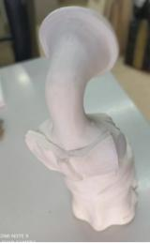

Career Counseling and Orientation in Artistic Professions

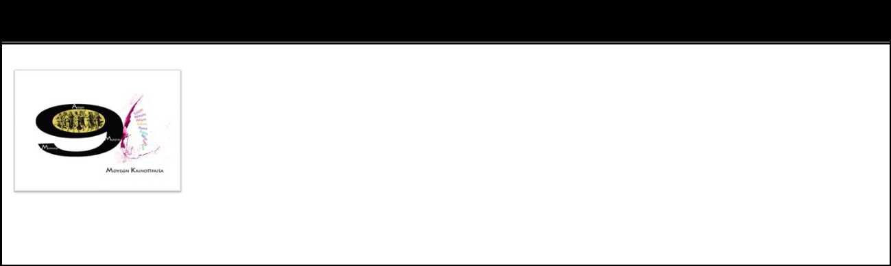
MOUSON KAINOPRAGIA Phase I 2017-

http://esai.gr/talent.html

For Dance and Drama A 3 hours process of measuring and evaluating basic fitness skills and special dance or drama skills, in combination with evaluation of eating habits and improvisation abilities. Personality traits are also screened according to standardized research tools.

For Music and Art (Painting/ Sculturing) The specific process is going to run for 1st time in May in Chania. There is not yet reference available.

On occasions, we have called disabled populations that are talented in a specific type of art to participate in the process, but we didnt have any response. In 2020 we are going to promote talent exhibitions for the disabled in cooperation with some officers of the public sector of secondary education.


New Artists’ Night

MOUSON KAINORAGIA Phase II 2004-

http://esai.gr/talent.html

 |  |  |  | Artists that participated in MOUSON KAINOPRAGIA Part I (Autumn), had the chance to expose
 |  |  |  | themselves to the public and to present their own creations with the supervision of their tutor
 |  |  |  | (Spring).
 |  |  |  | IN THIS PARTICULAR EVENT WE ALWAYS PROMOTE MINORITIES OR DISABLED, whatever the age, trying to promote a
 |  |  |  | new sense and logic of arts ! As more different THE ARTIST, as more interesting and STRANGE the artwork, OUT OF THE
 |  |  |  | ORDINAL & ORDINARY, a pure source of inspiration… and a reason for starting rhetorics and philosophy !
 |  |  |  | Sign Language DANCETHEATER 2005-
 |  |  | Dance Methodology for Deaf and Hearing People by using Signings and Sign Languge
 | https://handiedance.com |  |  | EERcomt promotes SL and dance-theater as a new very interesting process for
 |  |  |  | Improvisation and innovation. The current option of creative processing supports and
 |  |  |  | enhances collaboration within the deaf community, but not exclusively.
 |  |  |  | EERcomt has organised 7 projects with SL dance-theater since 2005.
 |  |  |  | In 2022 we decided to bring an innovative perspective of signing movement of the hands
 |  |  |  | and we promoted a new method of dancing based on digitalism, filming and half up body
 |  |  |  | movement (upper body, arms, hands, face) in several variations as to be possible and
 |  |  |  | for handicapped and we promote the HANDIEDANCE FESTIVAL. First year launched: March 2022
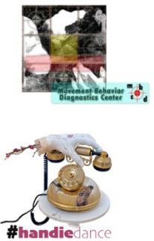

Jam Rhythm Dance 2015-


Dance Methodology for People with Attention Deficit or Hyperactivity Disorder

JRD is a new method of approaching youth with ADHD. The concept concerns the synthesis of dance, fitness and music tools within a context that is friendly and attractive to those persons. Many objects, materials, myths and stories are used in DMT applications and programs.


Artivia EU Youth Magazine 2018-

http://artivia.gr

It is a website where articles are uploaded written by our Youth that participates in our projects. The 2nd volume (2019) will be published online very soon.


YOUNG ACTIVE CITIZENS SUPPORT ECOLOGICAL ACTIONS

https://karatasoupark.org

New actions concerning Sustainable Environment (SINCE 2019), from 2020 and on.

Arts and Sports for the benefit of quality of life and Sustainable Environment. Young active volunteers set new elements and promote the local parks and hidden treasures of the city.

Achievements 2022/ entrance in the communities of:
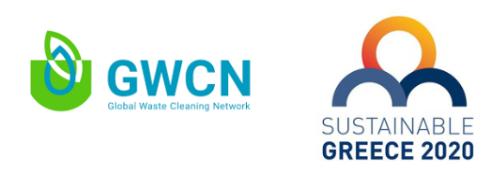

Distinctions in 2021
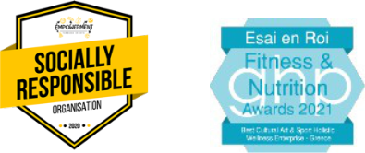

Official Member of
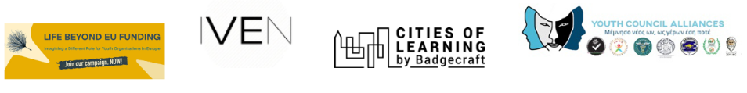

Standard Cooperation with:
